Get Ready Guide
{{GRG_DATE}}
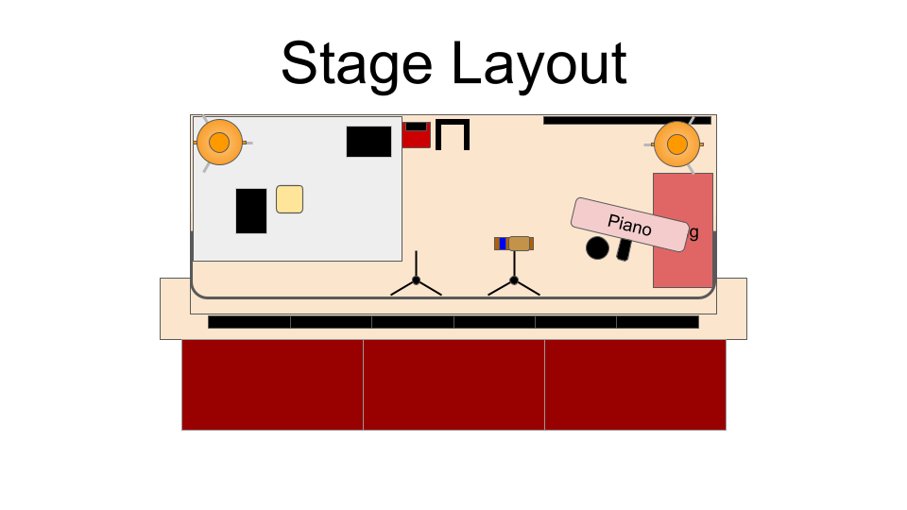
Expected Platform Team

BAND (SATURDAY 14:30 CALL)
- [Name | First-name Last Initial]: AC Gui or Keys
- [Name | First-name Last Initial]: Drums
- [Name | First-name Last Initial]: Keys

CHOIR (SUNDAY 7:30 CALL)
- [Name | First-name Last Initial]: WL
- [Name | First-name Last Initial]: Part Lead

ALL TEAM TECH RUN SUNDAY 08:00 CALL

Song List (Check PCO For Keys):

- {{GRG_SONG_LIST}}

{{GRG_SCANS_BEGIN}}

